**How to Qualify For the 2025**

**INTERGRATED TECHNOLOGY**

**MOBILE SHOPPING**

**DISCOUNT INCENTIVE – 3%**

**THIS INCENTIVE IS AVAILABLE FOR YOU TO USE ANY CONSECUTIVE SIX MONTH PERIOD OF TIME IN 2025.**

**FOLLOWING THE STEPS BELOW AND CLAIMING YOUR DISCOUNT WILL SAVE YOU 3% EACH WEEK.**

**Note: The promo ends 12/31/2025**

It’s relatively easy to qualify for this incentive program. The steps are as follows:

1. SECURE A COPY OF THE QUALIFIED AD THAT WAS PROVIDED BY ACP OR MFCP. You can find that ad on the ACP Website, MFCP website or create one of your own. Note: If you chose to make one of your own you must make certain the ad complies with the program guidelines.
2. SAVE THE CUSTOMIZED AD IN A FOLDER ON YOUR DESKTOP OR SOMEWHERE EASY TO FIND. (You are going to want to be able to easily access the ad when you apply for ad approval in the next few steps.)
3. SIGN INTO THE BUSINESS CUSTOMER GATEWAY
4. GO TO MAILING SERVICES – This is can be found on the upper left hand side of the site.
5. GO TO MAILING PROMOTIONS PORTAL. This can be found about half way down the page.
6. CLICK - SUBMIT MAILPIECE PRE-APPROVAL
7. GO TO INTEGRATED TECHNOLOGY PROMOTION. CLICK NEXT.
8. ENTER THE MAILPIECE TITLE - This is the name of your publication.
9. NEXT CHECK: MOBILE SHOPPING – 3%
10. TYPE THIS VERBIAGE INTO THE BOX THAT ASKS FOR DESCRIPTION:

*QR code in advertisement that when scanned, takes the user to a mobile optimized website where they can complete a purchase for Omaha Steaks.*

1. CHECK THE 2 BOXES BELOW
2. CLICK NEXT
3. FILL OUT CONTACT NAME (this is the name of the person in charge of the publication.)
4. COMPANY NAME (WHO’S DOING THE MAILING/INCHARGE OF PUBLICATION)
5. UPLOAD FILE OF THE AD WITH THE QR CODE – this is the one that we had you save in step 3.
6. CLICK NEXT
7. MAILPIECE APPROVAL FORM (AN EMAIL WILL BE SENT TO YOU WHEN APPROVED, THIS MAY TAKE A COUPLE HOURS)
8. SAVE THE EMAIL AND THE APPROVED AD (HIGHLY RECOMENDED) ….. WHEN SUBMITTING YOUR PUBLICATION TO THE POST OFFICE TO VERIFY, YOU WILL NEED TO CIRCLE THE AD EACH WEEK TO SHOW THAT IT HAS BEEN PRINTED IN THE PUBLICATION
9. MY MAILPIECE PREAPPROVAL HEADER – SHOWS WHICH PUBLICATIONS HAVE BEEN VERIFIED

Here is a sample ad that was created by the Association of Community Publishers. Once approved you need to run the ad every week in your paper to qualify for the discount that week. The ad can run in black and white or color. And, the size is at your discretion – a 2 column or 3 column generally works well.

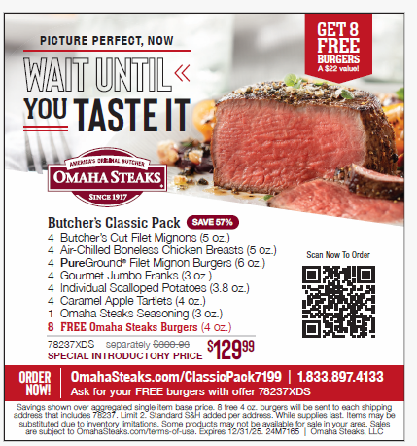

LET THE SAVINGS ROLL YOUR WAY!