**USPS POSTAL GATEWAY WEBSITE –**

**HOW TO CLAIM YOUR DISCOUNTS ….**

There are currently a number of discounts that can be taken when you submit your mailings. This document is intended to walk you through how to do that.

Throughout the document we have included a few screen shots. Some of them are a little hard to read. When viewing on your computer you can zoom in and then will be able to read the detail.

The **available** discounts in the document are:

***MARRIAGE MAIL INCENTIVE – SAVE 10%.*** The first discount you will want to select is the Marriage Mail Incentive. If you qualify you will save a total of 10% off your mailing cost that week. The requirement for this program is that you have a minimum of 4 advertisers (and, yes, display ads count) and that your entire package weigh less than 2 ounces (.125 pounds). In addition you will need to have a minimum of 10 qualified mailings per year. If you claim the discount and fail to the 10 required mailings, you will be billed back the discount.

***CONTAINERIZATION DISCOUNT* –** The discount is available for folks that mail EDDM – either SCF or DDU.

**INTERGRATED TECHNOLOGY –MOBILE SHOPPING - 3% DISCOUNT -** *For this discount you are required to run a pre-approved ad each week. When you submit your mailing, you will need to circle in* ***RED*** *marker the pre-approved ad within the printed paper and submit that with your paperwork to the post office. Failing to do this will result in not getting* ***YOUR*** *discount*

***The New Sustainability Add-On***

This ***Add-On*** encourages mailers to adopt a higher level of recyclable paper in their mailings by offering an additional 1% discount to mailers who demonstrate the paper used in their mailings is responsibly sourced and sustainably produced by exhibiting an eligible certification.

1. GO TO THE POSTAL GATEWAY
2. CHOOSE 3602 MARKETING MAIL TAB
3. FILL OUT INFORMATION AND THEN NEXT.

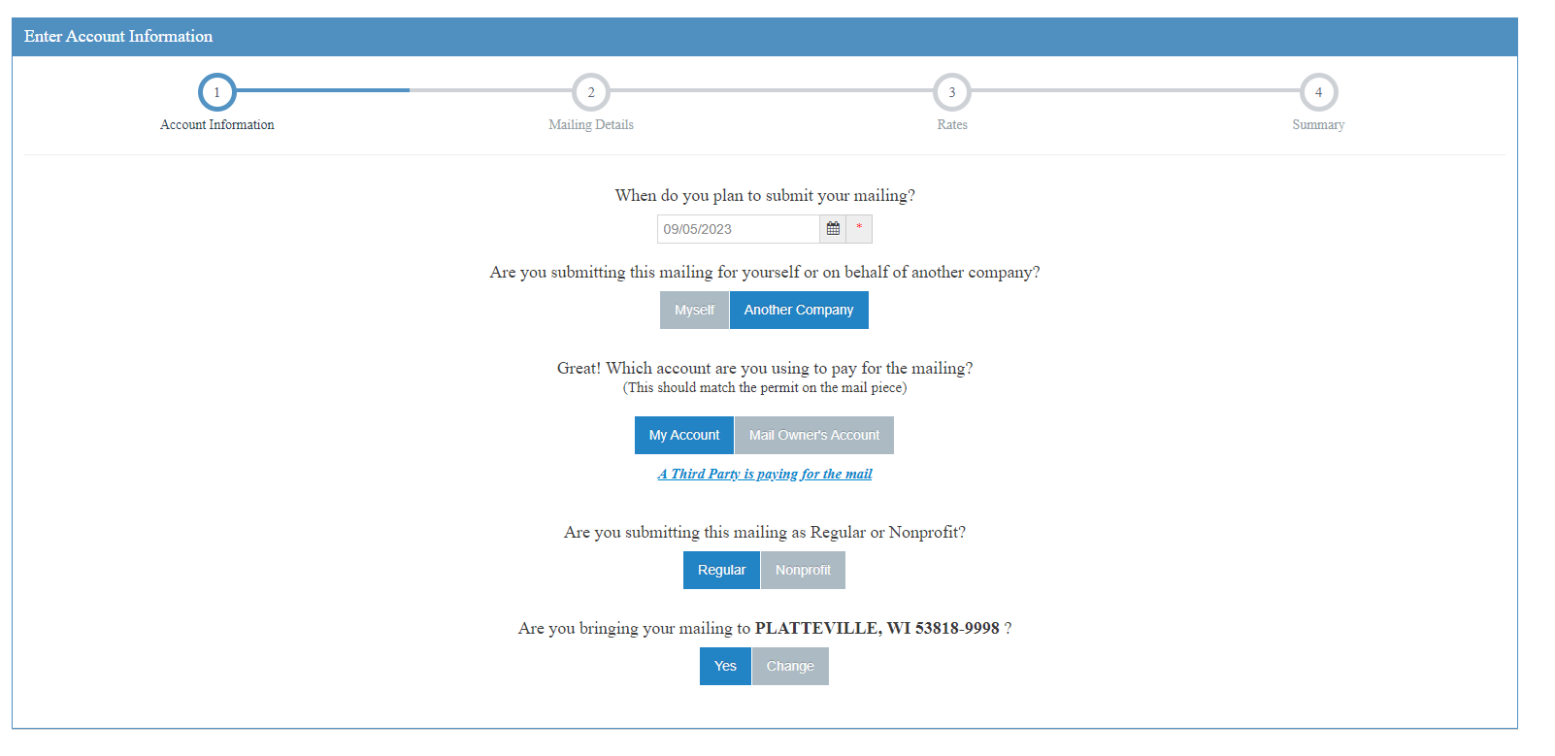

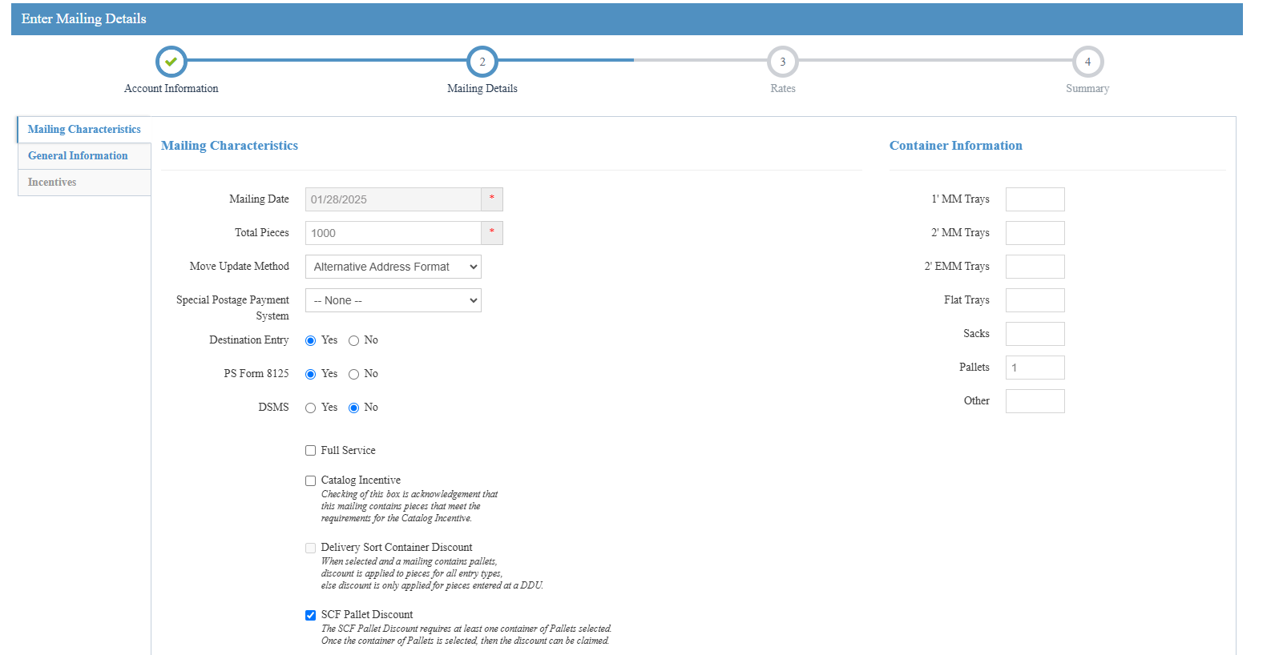

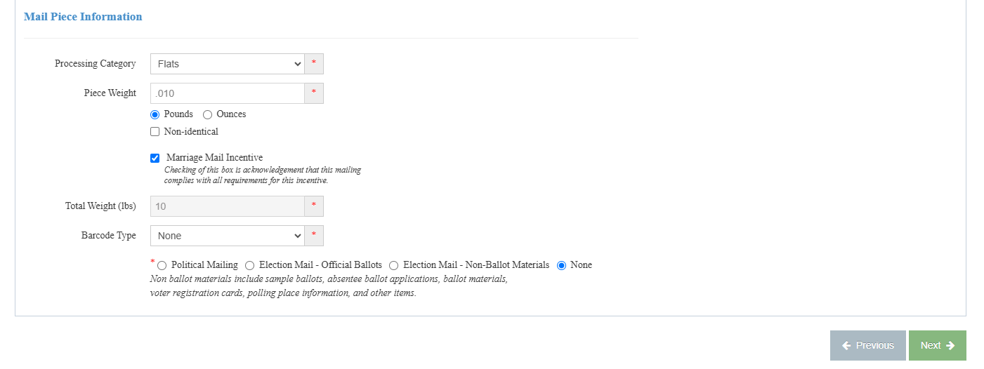

1. FILL OUT MAILING CHARACTERISTICS

***CLICK ON THE MARRIAGE MAIL INCENTIVE WHICH IS LOCATED UNDER THE MAIL PIECE INFORMATION SECTION – LEFT HAND SIDE OF THE PAGE

***MAILING MUST BE UNDER 2 OZ. OR .125 in POUNDS***

After you’ve completed this page, click on the GENERAL INFORMATION TAB.

ANOTHER DISCOUNT YOU SHOULD TAKE ADVANTAGE OF IS THE

CONTAINERIZATION DISCOUNT.

1. FOR CONTAINERIZATION DISCOUNT – you are **ONLY** allowed to take one type of containerization discount per mailing. In the section entitled: FLATS EDDM you will enter the mailing quantity for each type of product – NONE, DSCF OR DDU (those are your options). YOU CAN ONLY DO ONE CHOICE FOR YOUR MAILING. EITHER DDU OR SCF. YOU CAN ONLY DO ONE CHOICE PER MAILING.

***NONE RATE DOES NOT QUALIFY FOR THE CONTAINERIZATION DISCOUNT ***

1. You will see the RATE DISCOUNT per piece to the right of the quantities. Do the math and pick the mailing type that will give you the biggest discount. Again, this is because you can only have one type of containerization discount for your entire mailing.
2. THAT SHOULD FINISH UP THE CONTAINERIZATION DISCOUNT.
3. NEXT IS THE MARRIAGE MAIL DISCOUNT
4. TO FINISH THE “MARRIAGE DISCOUNT” YOU MUST FILL OUT THAT SECTION
5. Enter the quantity of each type of each type of mailing category: You will want to use the following lines: F58= NONE. F62= SCF, F64=DDU.
6. FILL OUT GENERAL INFORMATION TAB INFORMATION. When complete click NEXT.

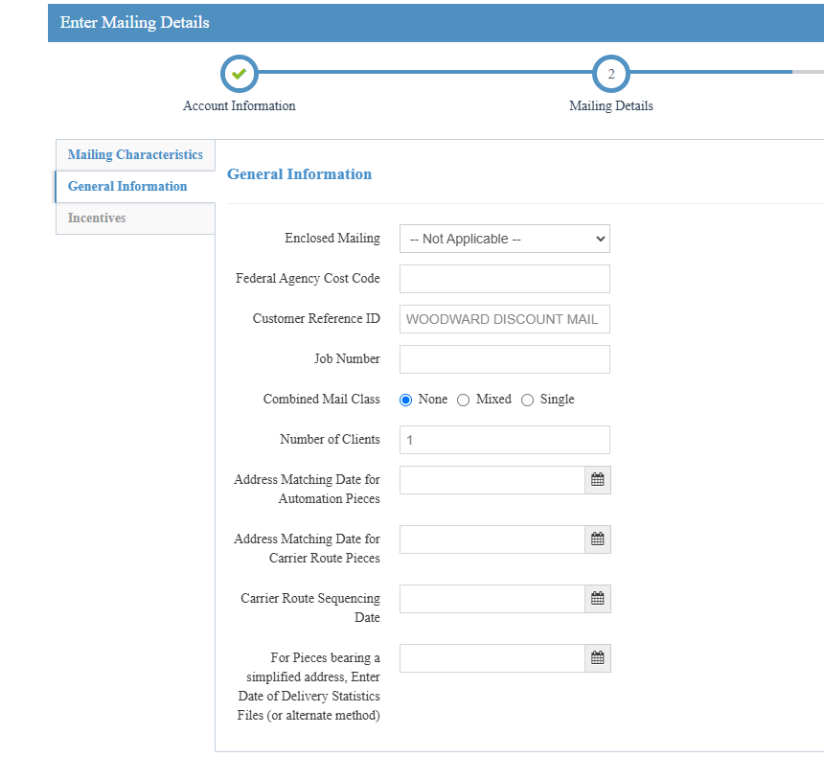

1. FILL OUT INCENTIVES TAB

***THIS IS THE PAGE WHERE YOU CLICK TO CLAIM THE INTERGRATED TECHNOLOGY- 3% DISCOUNT AND THE SUSTAINABILITY ADD ON DISCOUNT (1%).

*NOTE:* *For this discount you are required to run a pre-approved ad each week. When you submit your mailing you will need to circle the pre-approved ad within the printed paper and submit that with your paperwork to the post office. Failing to do this will result in your not getting the discount.*

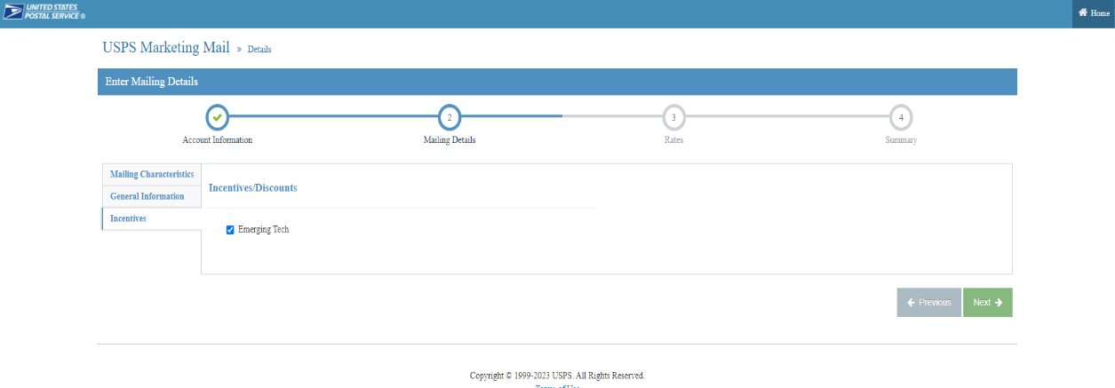13) NEXT – FILL OUT CATERGORIES (DDU F22/SCF F21/NONE F19 RATES)

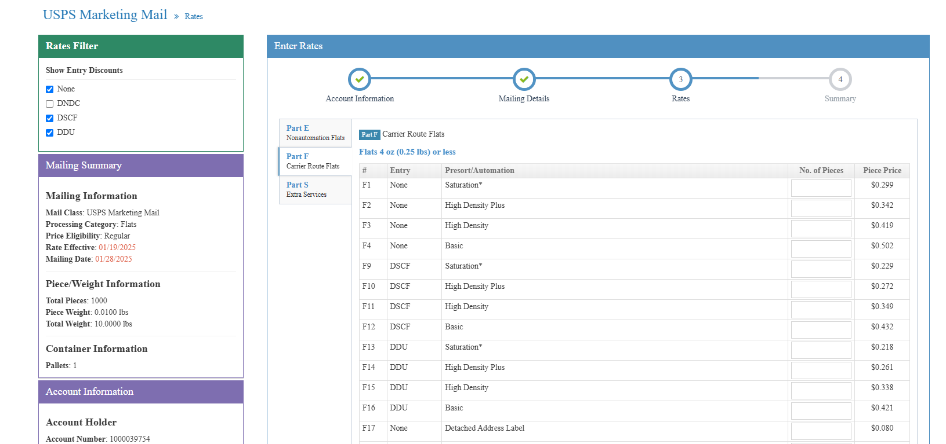

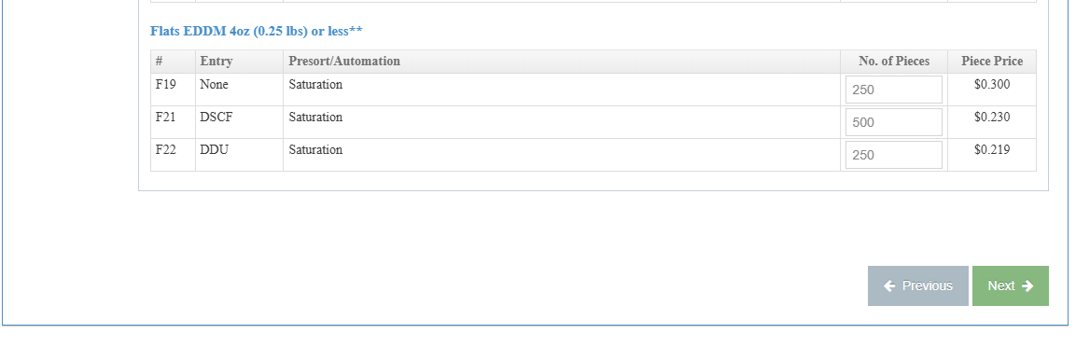

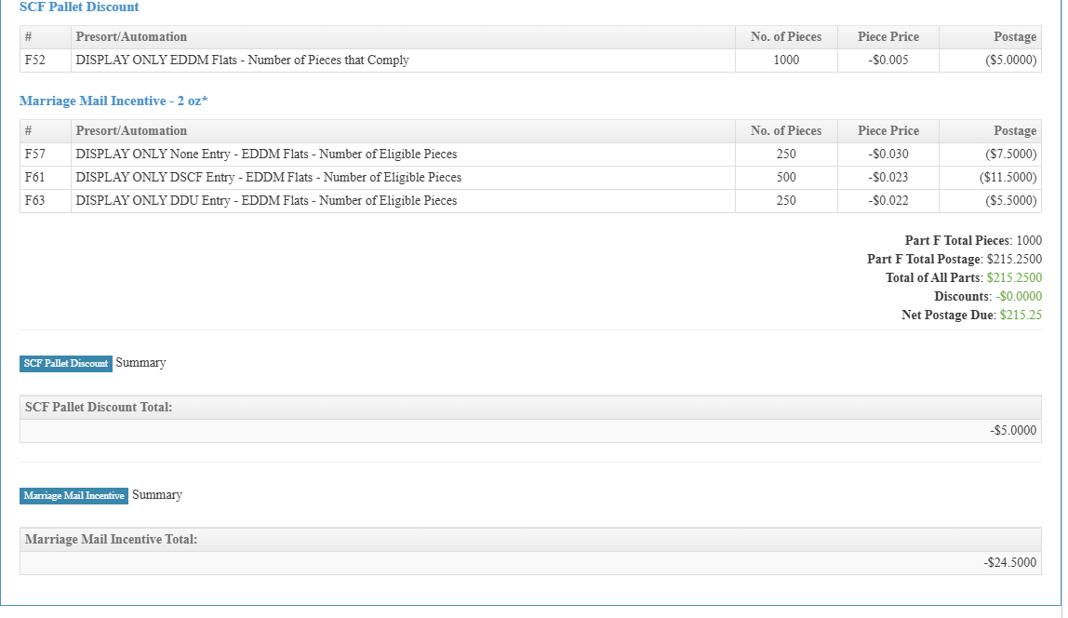

***SOMETHING NEW YOU WILL SEE IS THE DISCOUNTS WILL APPEAR AT THEN END BEFORE UPLOADING TO THE DASHBOARD***ALL DISCOUNTS WILL APPEAR IN THIS SECTION***

***AT THE TIME OF DOING THIS DEMO NOT ALL DISCOUNTS WERE NOT AVAILABLE, THAT’S WHY THYE DID NOT SHOW UP IN THE SCREEN SHOT***